Web Application Vulnerability Assessment Report
Student Name:Paulson k Babu

1. Introduction
This report presents the results of a web application vulnerability assessment conducted using OWASP ZAP (Zed Attack Proxy). The target application used for testing was OWASP Juice Shop, an intentionally vulnerable web application designed for security training. The purpose of this assessment is to identify vulnerabilities and map them to the OWASP Top 10 categories.

2. Tools Used
• Kali Linux
• Docker
• OWASP Juice Shop (Target Application)
• OWASP ZAP (Security Testing Tool)

3. Methodology
1. Installed and ran OWASP Juice Shop using Docker.
2. Accessed the application at http://localhost:3000.
3. Launched OWASP ZAP.
4. Performed an Automated Scan on the target URL.
5. Analyzed the alerts generated by ZAP.
6. Mapped identified vulnerabilities to OWASP Top 10 categories.

4. Vulnerability Findings

4.1 SQL Injection
Description:
SQL Injection is a vulnerability that allows attackers to manipulate database queries by inserting malicious SQL code into input fields.
Risk Level: High
Evidence:
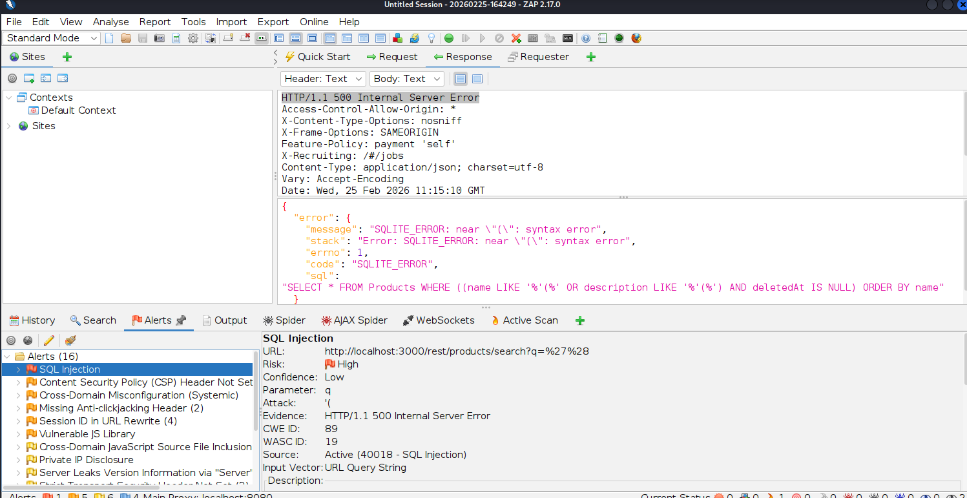OWASP Top 10 Category:
A03 – Injection
Explanation:
This vulnerability matches OWASP Top 10 A03: Injection because the attacker injects malicious SQL commands into application input fields. The application fails to properly validate user input before sending it to the database.
Impact:
Unauthorized data access
Data modification
Database deletion
Bypass authentication

4.2Cross Domain Misconfiguration
Description:
Cross Domain Misconfiguration occurs when a web application improperly configures Cross-Origin Resource Sharing (CORS). This may allow external domains to access sensitive resources from the application.
Risk Level: Medium
Evidence:
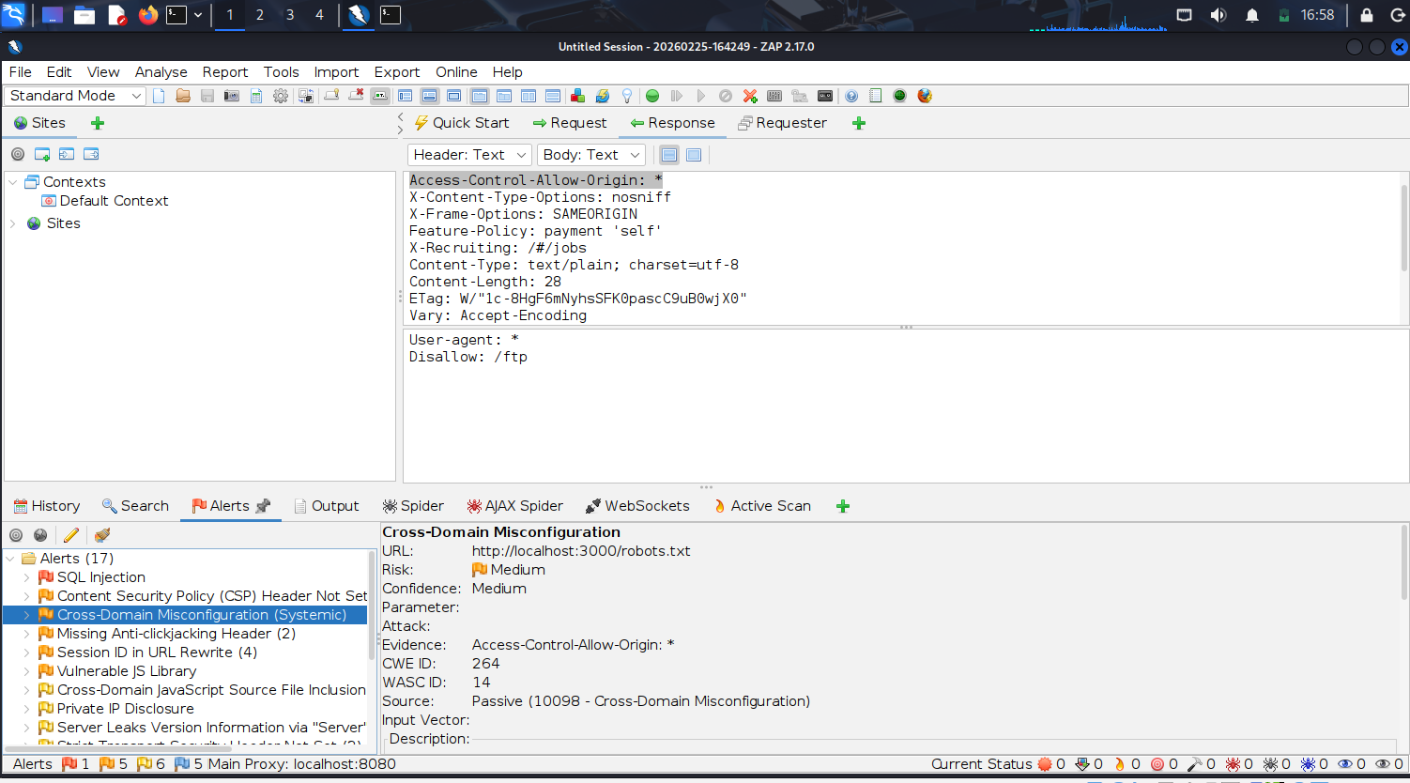
OWASP Top 10 Category:
A05 – Security Misconfiguration
Explanation:
This vulnerability matches OWASP Top 10 A05: Security Misconfiguration because the server is incorrectly configured to allow cross-origin requests. Improper CORS configuration may allow attackers to access sensitive data from other domains.
Impact:
- Unauthorized data access
- Data leakage
- API abuse

5. Conclusion
The assessment identified multiple vulnerabilities in the OWASP Juice Shop application. These vulnerabilities align with the OWASP Top 10 security risks. Automated scanning tools like OWASP ZAP are effective in identifying common security issues, but secure coding practices and proper configuration are essential to prevent such vulnerabilities.

